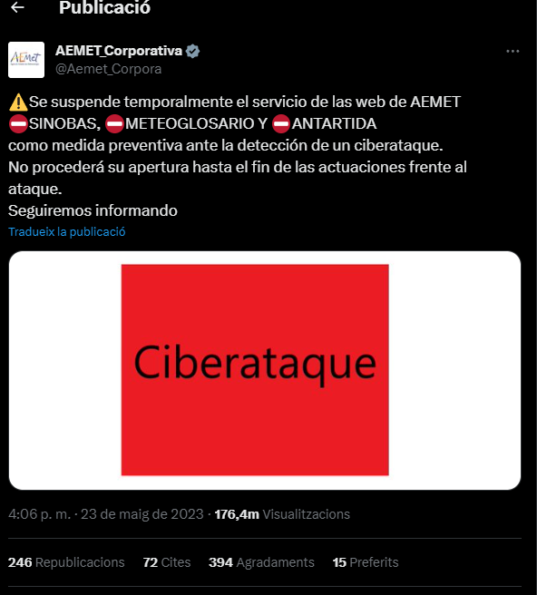

CENTROS DE INVESTIGACION DE LAS ISLAS DE GEORGIA DEL SUR:  
La estación de investigación de Bird Island, operada por el BAS.

[Bird Island Research Station - British Antarctic Survey (bas.ac.uk)](https://www.bas.ac.uk/polar-operations/sites-and-facilities/facility/bird-island/)

La estación de investigación de South Georgia, operada por la Universidad de Cambridge.

[King Edward Point Research Station - British Antarctic Survey (bas.ac.uk)](https://www.bas.ac.uk/polar-operations/sites-and-facilities/facility/king-edward-point/)

La estación de investigación de Zavodovski, operada por la Universidad de Oxford.

[Zavodovski Expedition - British Antarctic Survey (bas.ac.uk)](https://www.bas.ac.uk/project/zavodovski-expedition/)

CIBERATAQUES MARITIMOS

[Cyber Security in the Maritime Industry: A Systematic Survey of Recent Advances and Future Trends (strath.ac.uk)](https://strathprints.strath.ac.uk/79111/1/Ben_Farah_etal_Information_2022_Cyber_security_in_the_maritime_industry.pdf)

[Cyber Security Aspects in the Maritime Sector — ENISA (europa.eu)](https://www.enisa.europa.eu/publications/cyber-security-aspects-in-the-maritime-sector-1)

[Maritime cybersecurity threats: Gaps and directions for future research - ScienceDirect](https://www.sciencedirect.com/science/article/abs/pii/S0964569123000182)

[La lucha contra la piratería en Somalia: el problema persiste a pesar del esfuerzo militar (ARI) - Real Instituto Elcano](https://www.realinstitutoelcano.org/analisis/la-lucha-contra-la-pirateria-en-somalia-el-problema-persiste-a-pesar-del-esfuerzo-militar-ari/)